EX1:
#define _CRT_SECURE_NO_WARNINGS
#include <stdio.h>
int isPrime(int num) {
if (num <= 1)
return 0;
for (int i = 2; i * i <= num; i++) {
if (num % i == 0)
return 0;
}
return 1; }
void primeBetweenIntervals(int start, int end) {
printf("Prime numbers between %d and %d are:", start, end);
for (int i = start; i <= end; i++) {
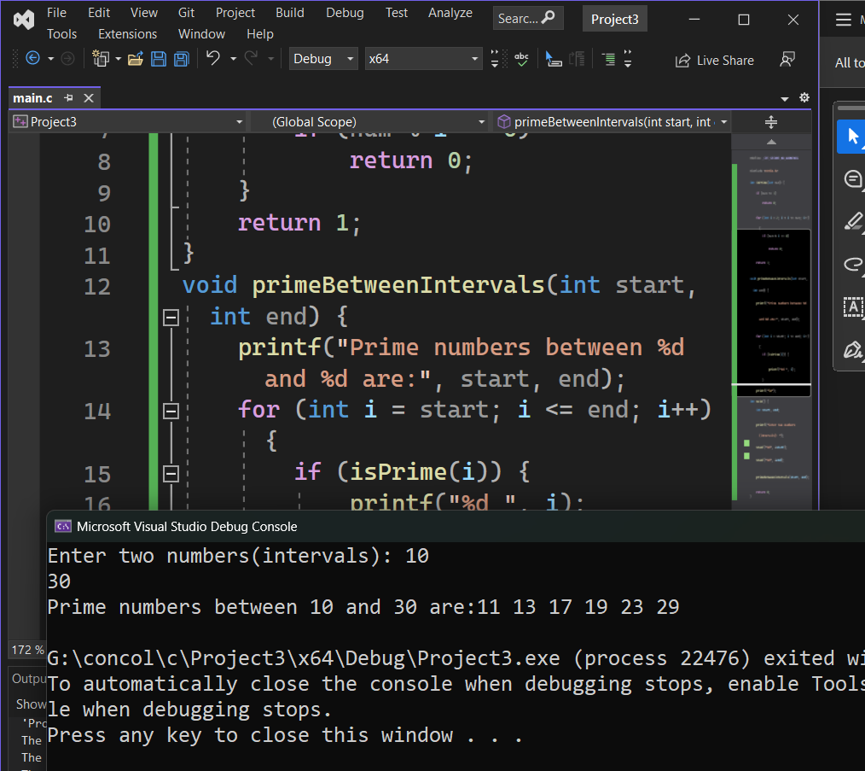
if (isPrime(i)) {
printf("%d ", i);
} }
printf("\n");}
int main() {
int start, end;
printf("Enter two numbers(intervals): ");
scanf("%d", &start);
scanf("%d", &end);
primeBetweenIntervals(start, end);
return 0;
}
Ex2:
#define _CRT_SECURE_NO_WARNINGS
#include <stdio.h>
long long factorial(int n) {
if (n == 0 || n == 1)
return 1;
else
return n * factorial(n - 1);
}

int main() {
int num;
long long fact;
printf("Enter an positive integer: ");
scanf("%d", &num);
if (num < 0) {
printf("Factorial is not defined for negative numbers.\n");
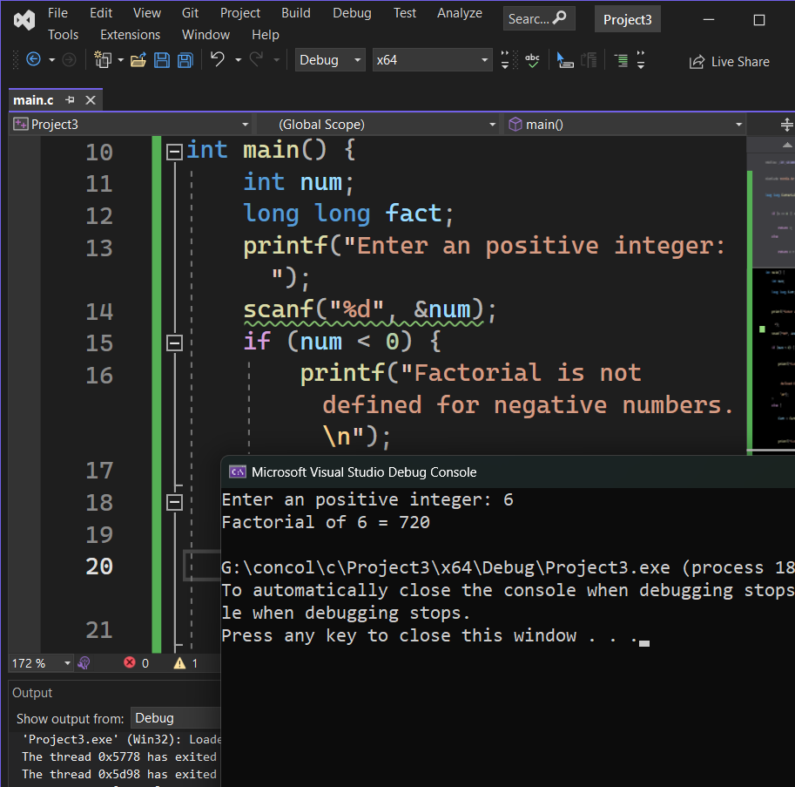
}
else {
fact = factorial(num);
printf("Factorial of %d = %lld\n", num, fact);
}
return 0;
}

Ex3:
#define _CRT_SECURE_NO_WARNINGS
#include <stdio.h>
#include <string.h>
void reverseSentence(char str[], int index) {
if (str[index] == '\0')
return;
reverseSentence(str, index + 1);
printf("%c", str[index]);
}

int main() {
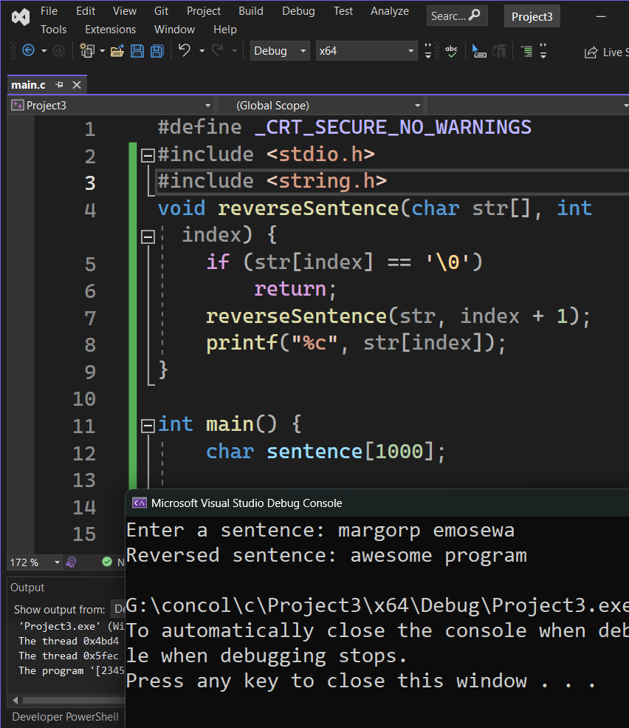
char sentence[1000];

printf("Enter a sentence: ");
fgets(sentence, sizeof(sentence), stdin);

sentence[strcspn(sentence, "\n")] = 0;
printf("Reversed sentence: ");
reverseSentence(sentence, 0);
printf("\n");
return 0;
}

Ex4:
#define _CRT_SECURE_NO_WARNINGS
#include <stdio.h>
double power(double base, int exponent) {
if (exponent == 0)
return 1;
else if (exponent > 0)
return base * power(base, exponent - 1);
else
return 1 / power(base, -exponent);
}
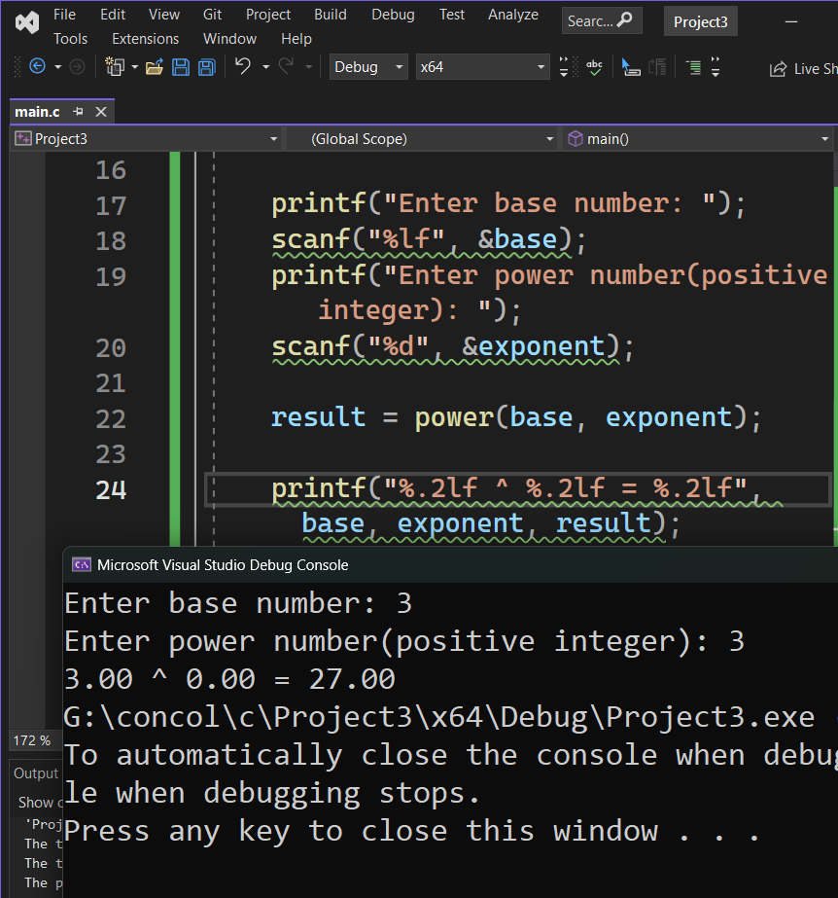
int main() {
double base;
int exponent;
double result;
printf("Enter base number: ");
scanf("%lf", &base);
printf("Enter power number(positive integer): ");
scanf("%d", &exponent);
result = power(base, exponent);
printf("%.2lf ^ %.2lf = %.2lf", base, exponent, result);
return 0;
}

